 | Course Name: Design Patterns/Thinking LAB | EXPERIMENT NO. 14
 | Course Code: 20CP210P  Faculty: Dr. Payal Chaudhari | Branch: CSE | Semester: IV
(To be filled by Student)
Submitted by: Meet Jain
Roll no: 23BCP093

Objective: To familiarize students with standard Behavioral design patterns.
Experiment: Explain the Iterator design pattern and write a program using any object-oriented programming language to demonstrate the working of Iterator design pattern.

Code:

interface Iterator {
boolean hasNext();
Object next();
}

interface Container {
Iterator getIterator();
}

class NameRepository implements Container {
public String[] names = {"Alice", "Bob", "Charlie", "Diana"};

public Iterator getIterator() {
return new NameIterator();
}

private class NameIterator implements Iterator {
int index;

public boolean hasNext() {
return index < names.length;
}

public Object next() {
return this.hasNext() ? names[index++] : null;
}
}
}

public class IteratorPattern{
public static void main(String[] args) {
NameRepository nameRepo = new NameRepository();

for (Iterator iter = nameRepo.getIterator(); iter.hasNext(); ) {
String name = (String) iter.next();
System.out.println("Name: " + name);
}
}
}

Output:
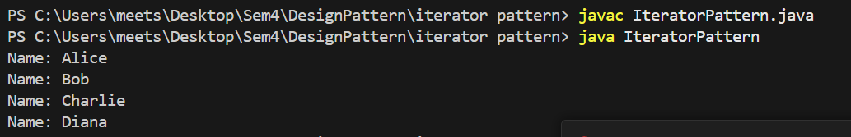
Class Diagram:
